**Report notes**

**1.Diffusion model for stochastic parameterization(随机参数化)**

1.Al

a. classification

b. regression/inter

c. disentanglement

d. representation

e. sampling

2. Skilful precipitation nowcasting using deep generative models of radar

**AI Oceanography**

1. **AI and Big Ocean Data-Big Data challenge**

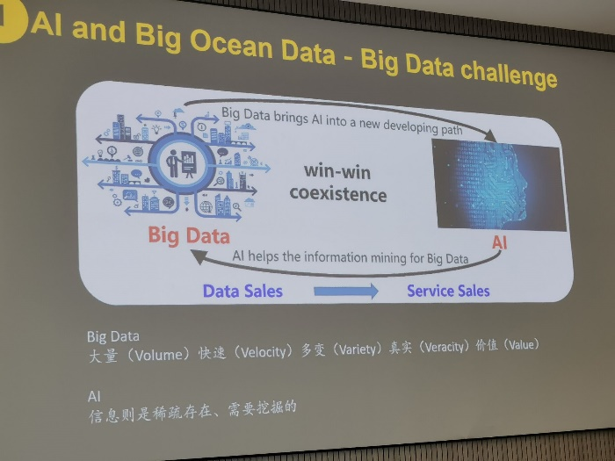

1. **DeepLearning**

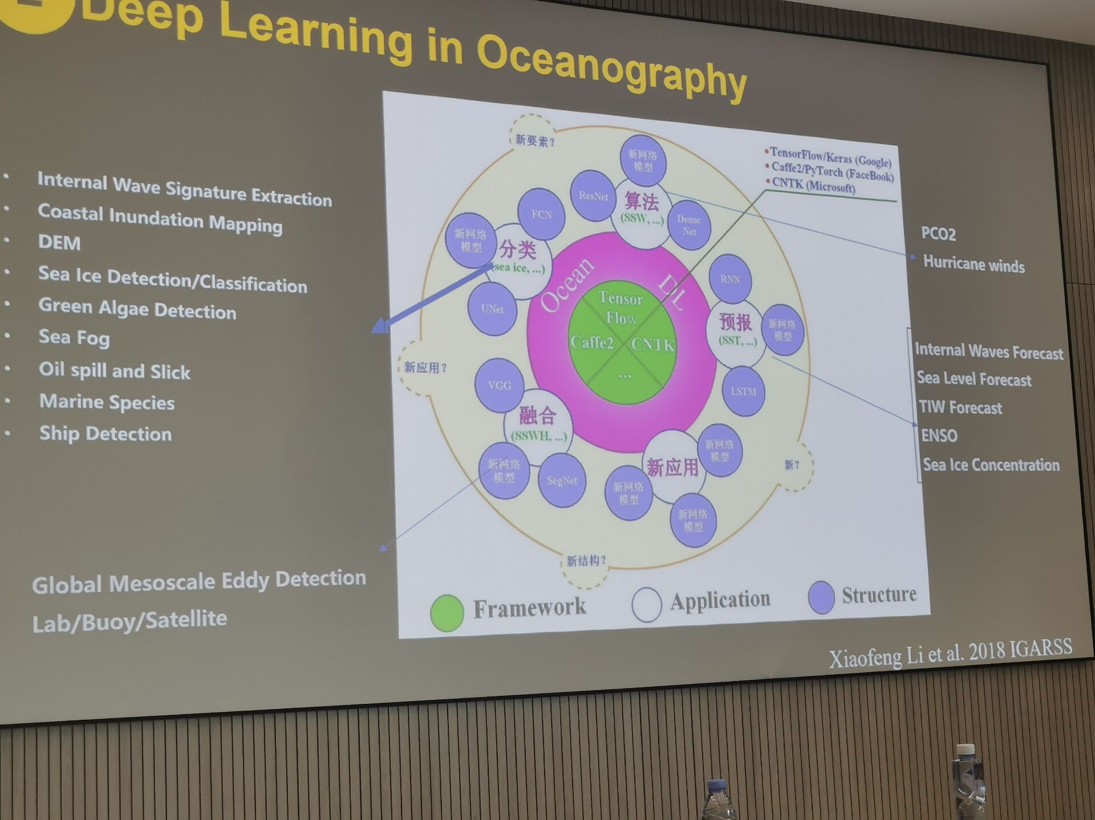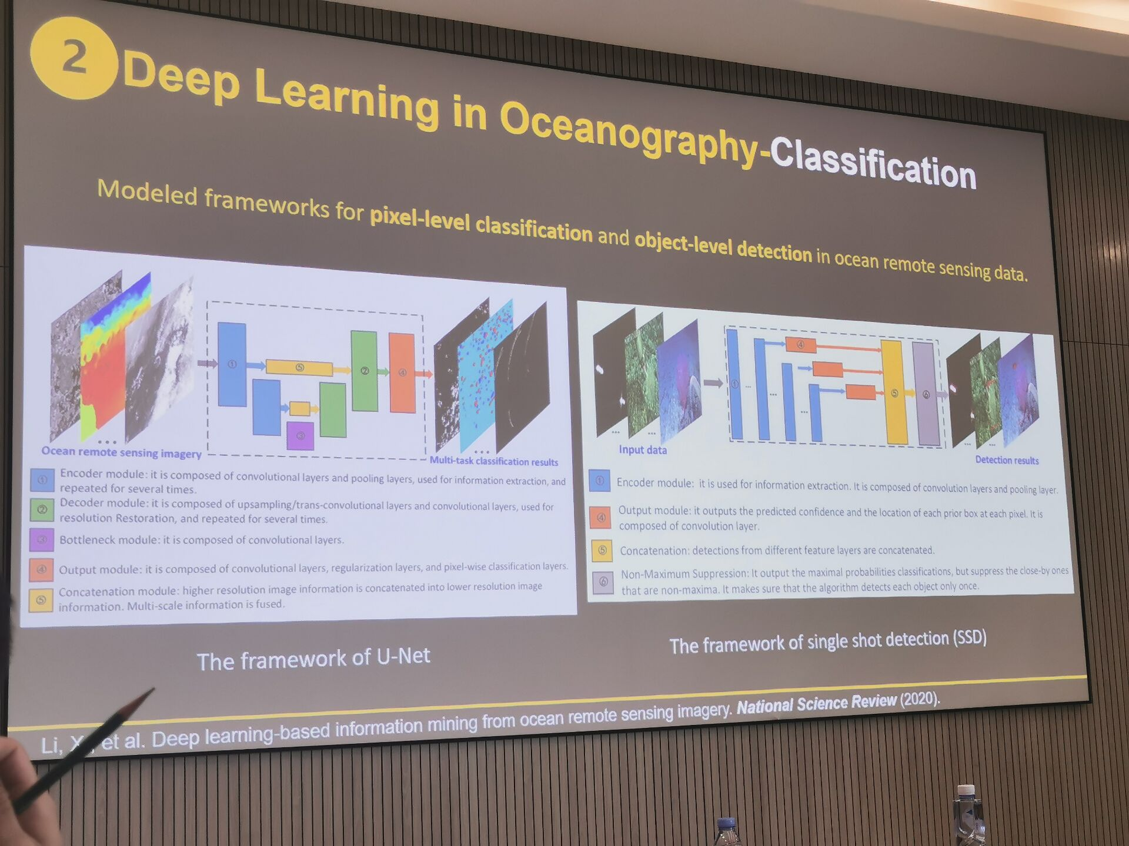

**Classification:**

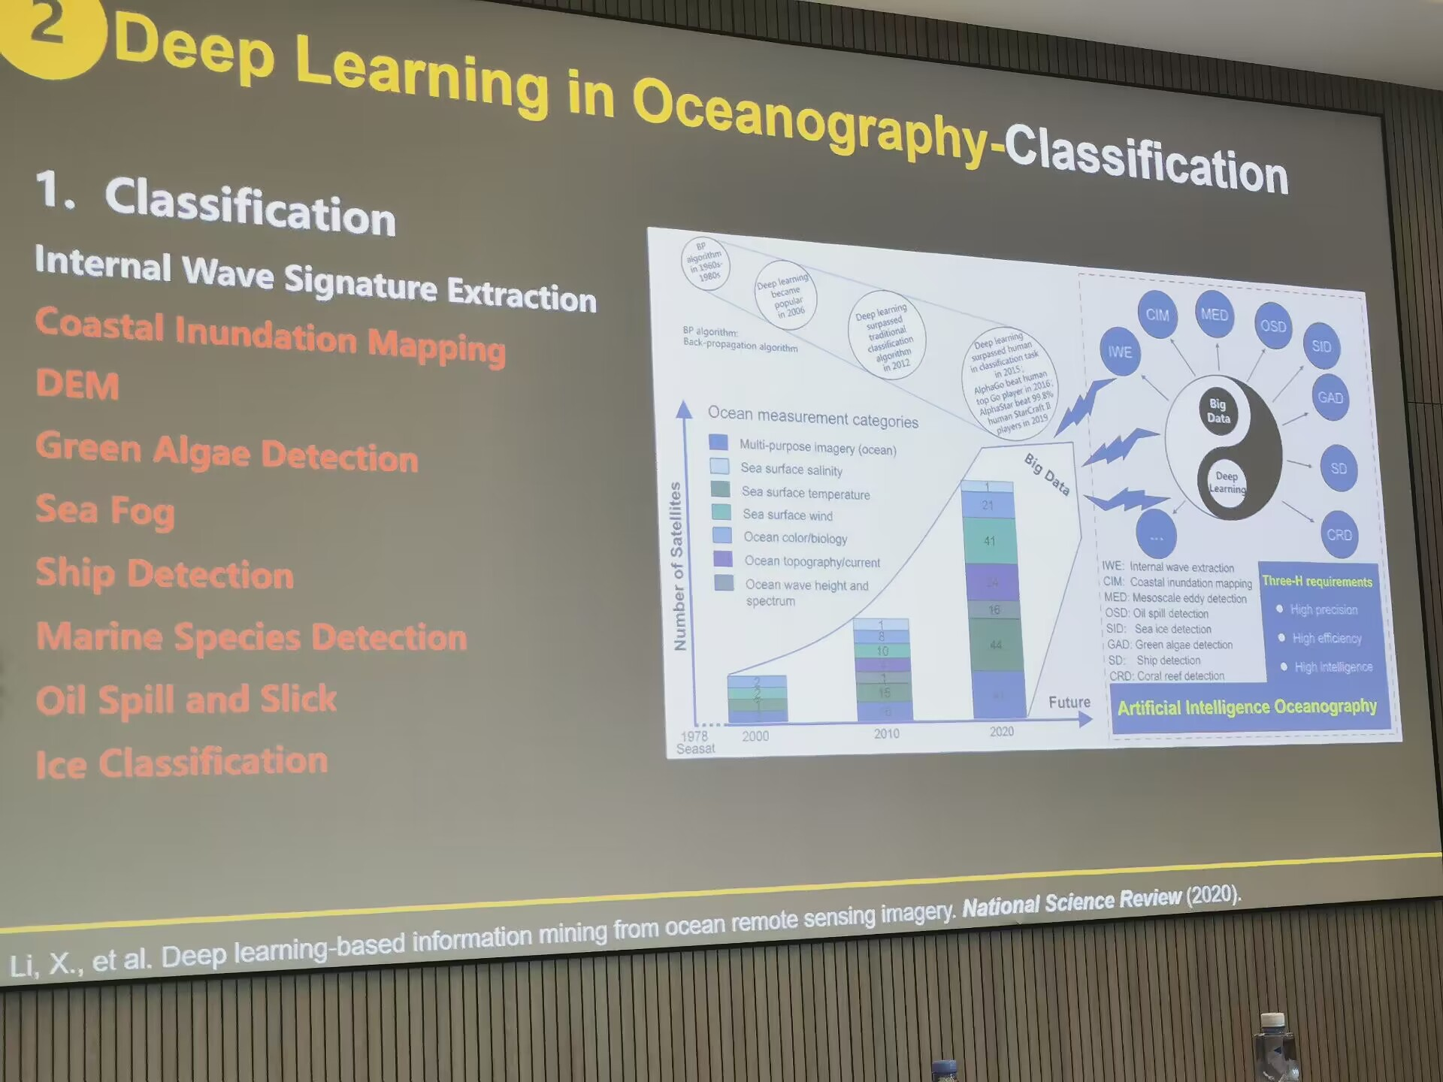

**2.1.1coastal inundation(淹没)**

**2.1.2automatic waterline extraction of tidal flats**

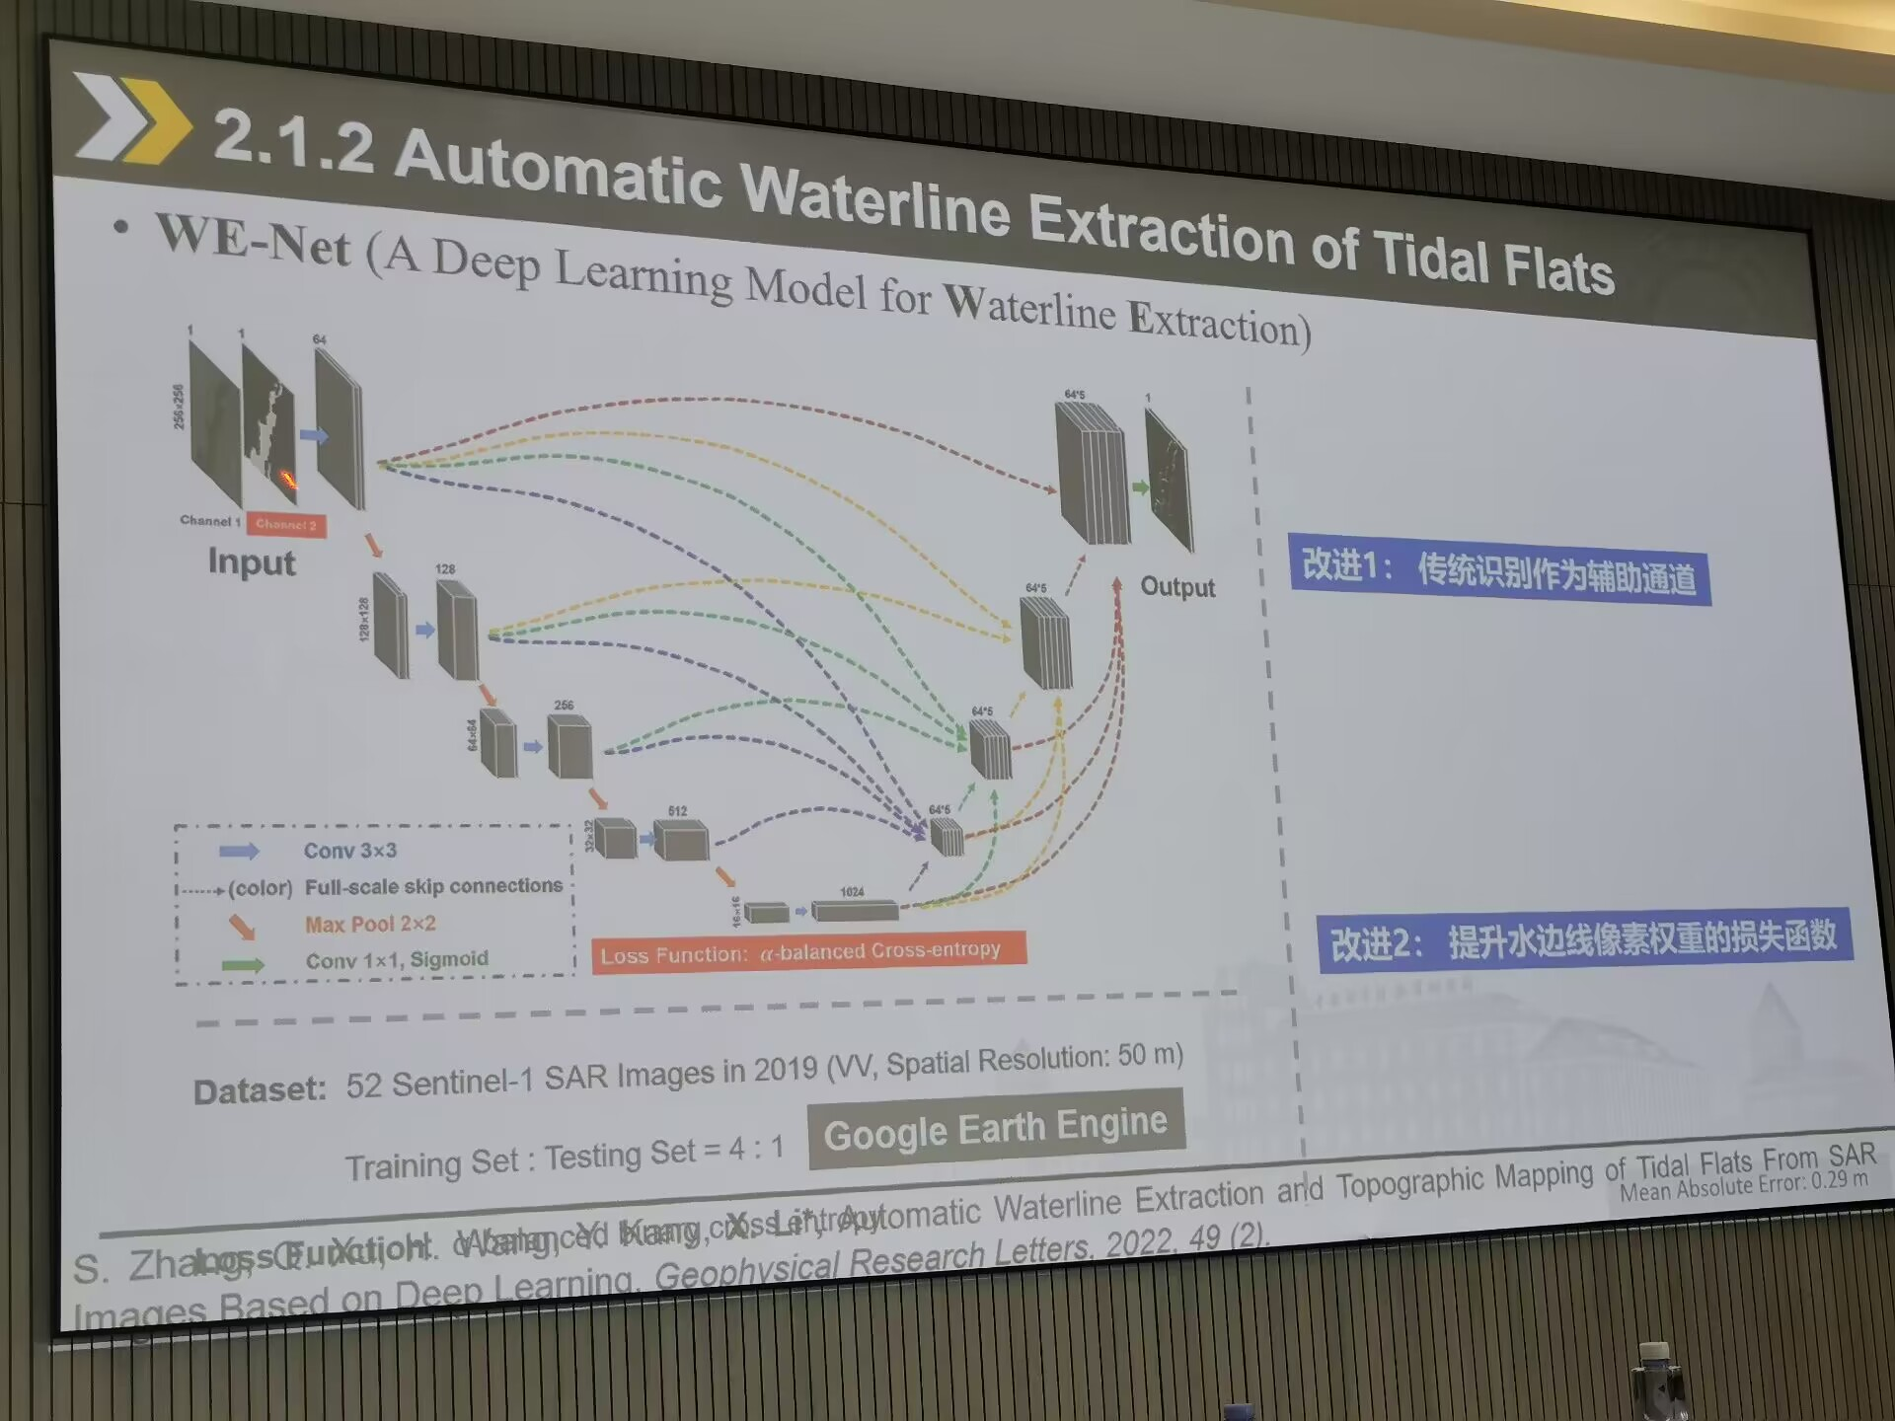

**2.1.3detecting floating green algae**

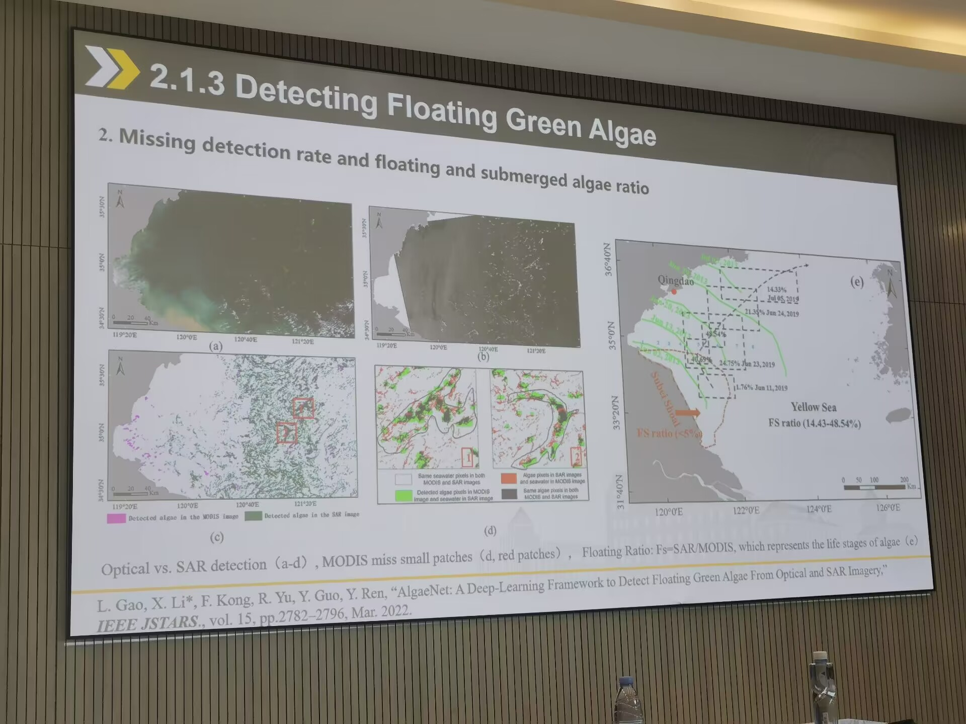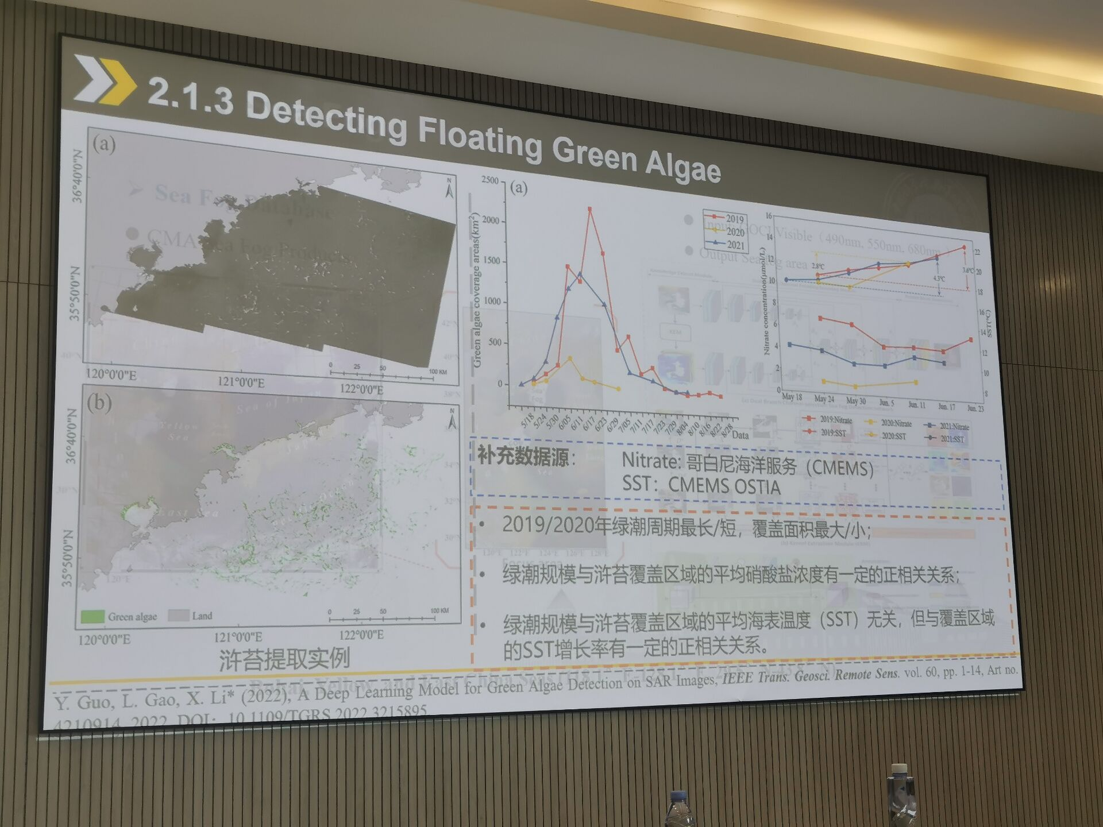

**2.1.4sea fog**

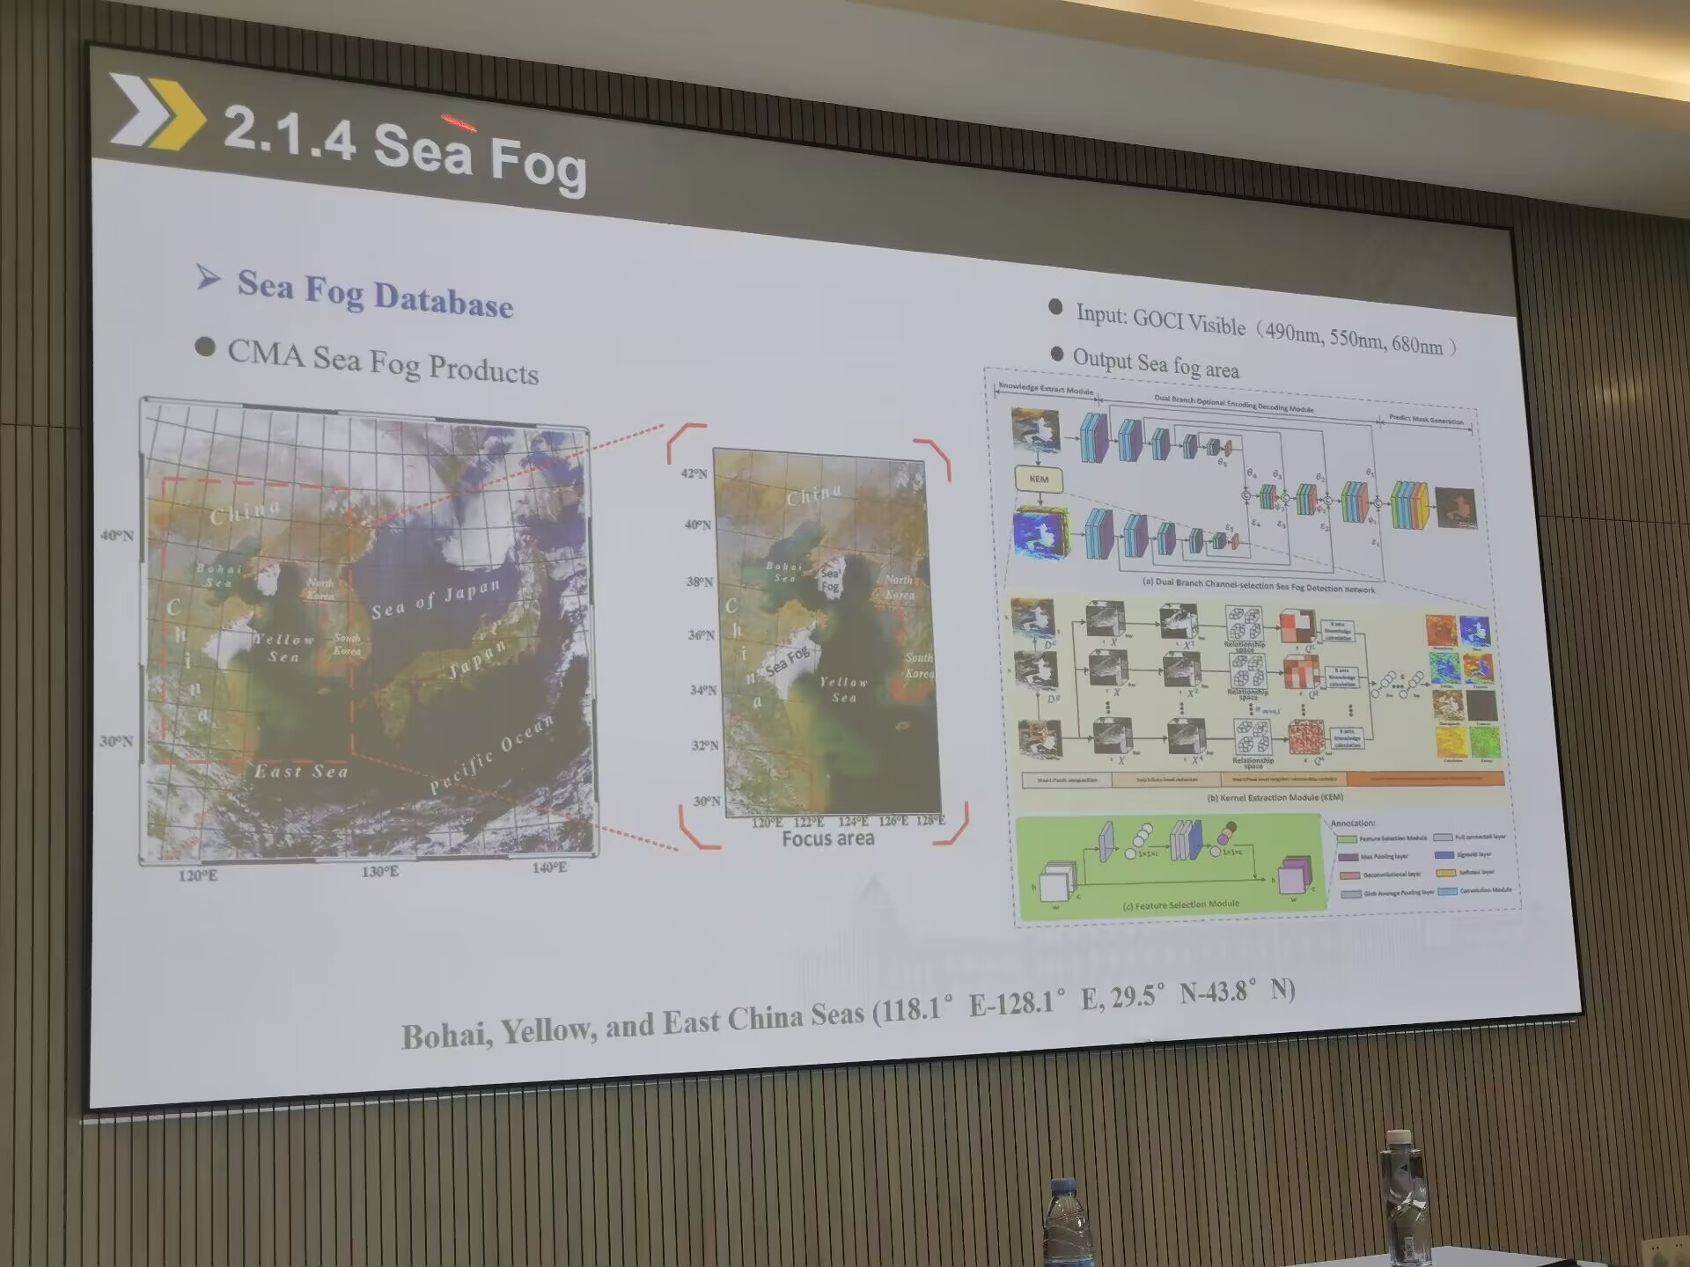

**2.1.5marine species detection**

1. **Discussion**